**Bug 1: Capitalization Issue – "Annual Meeting" - Done**

**Steps to Reproduce:**

1. Navigate through the application.
2. Locate instances where "Annual Meeting" appears.
3. Observe inconsistent capitalization of the word "Meeting."

**Expected Result:**

* The “Annual Meeting" should always have the "M" capitalized across the application.

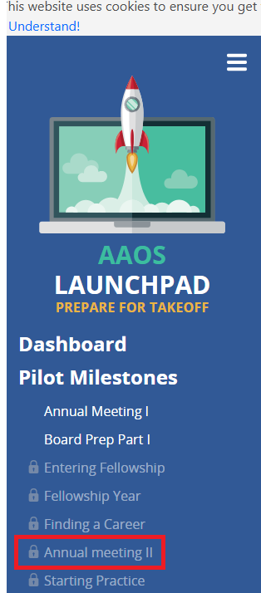

**Bug 2: Incorrect Formatting in "From Training to Practice" Description - Done**

**Steps to Reproduce:**

1. Go to the main dashboard.
2. Locate the description for "From Training to Practice."
3. Observe the text “Board Exams Part 1 and Part 2.”

**Expected Result:**

* The text should be updated to “Board Exams Part I and Part II.”

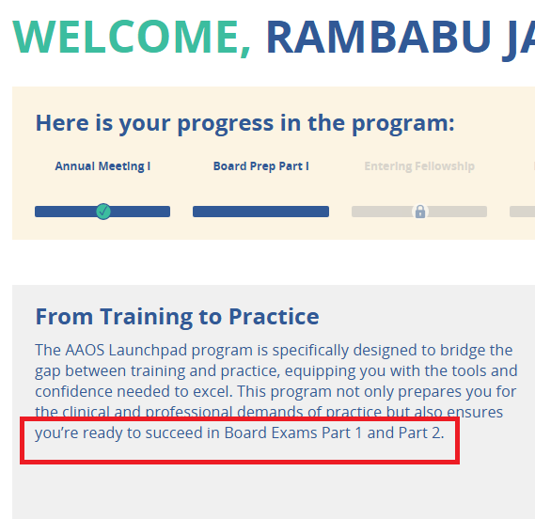

**Bug 3: Font Size in Notifications Block is Too Small – Done**

**Steps to Reproduce:**

1. Navigate to the Notifications block on the dashboard.
2. Compare the font size with the text in "From Training to Practice."

**Expected Result:**

* The font size in the Notifications block should match the font size in "From Training to Practice."

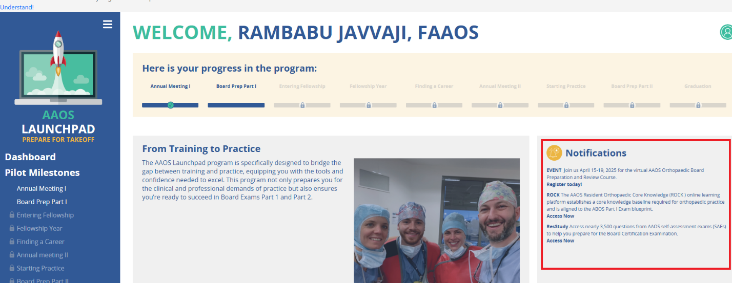

**Bug 4: Insufficient Padding in Left Navigation Box - Done**

**Steps to Reproduce:**

1. View the left navigation panel.
2. Observe that the text is too close to the left edge.

**Expected Result:**

* Increase the padding so that the text is properly spaced from the left edge.

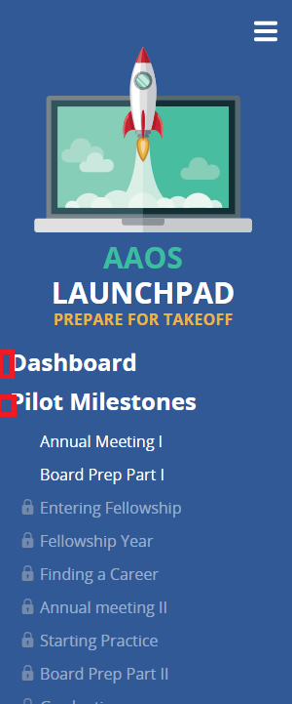

**Bug 5: Logo and Laptop Text Alignment Issue - Done**

**Steps to Reproduce:**

1. Navigate to the section containing the logo and laptop.
2. Observe that the text underneath the laptop is not as wide as the laptop.

**Expected Result:**

* The text under the laptop should be as wide as the laptop for proper alignment.

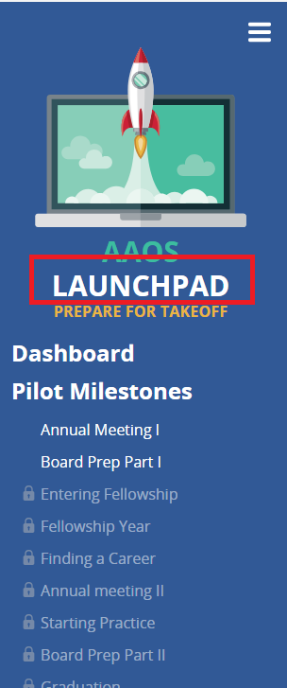

**Bug 6: Bug: Footer Not Displaying Due to Cookie Consent Message (Affects Desktop & Mobile)**

Steps to Reproduce:

1. Open the website on a desktop browser in the QA environment.
2. Observe that a cookie consent message appears:  
   *"*This website uses cookies to ensure you get the best experience on our website. Learn more I Understand!"
3. Notice that the footer is not displaying because it is getting cut off.
4. The AAOS logo is also not visible due to the footer being hidden.
5. Repeat the same steps on a mobile device or responsive mode and observe the same issue.

Expected Result:

* The footer and AAOS logo should be fully visible on both desktop and mobile, and the cookie consent message should not interfere with the footer layout.

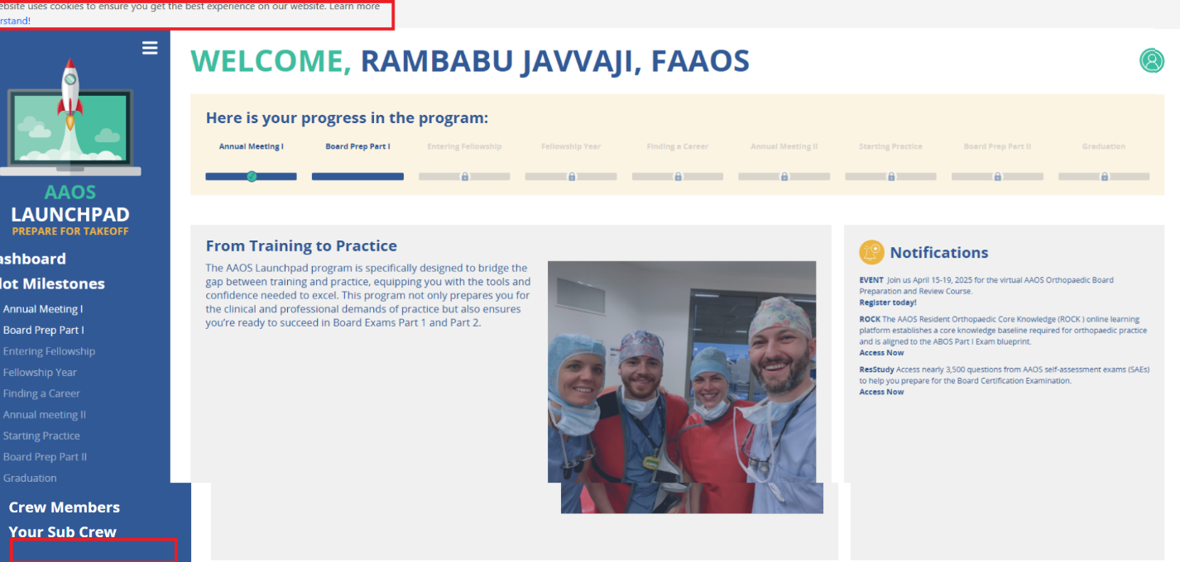

**7.Bug: Responsiveness: UI Overlap Issue in Landscape Mode (Left Navigation Panel) – As per figma , Left nav should overlap. As we add same thing like desktop, content won’t be visible.**

Steps to Reproduce:

1. Open the website in a browser (Chrome/Edge/Firefox).
2. Open DevTools
3. Toggle Device Toolbar and select a mobile device (e.g., iPhone, iPad, Galaxy).
4. Rotate to Landscape Mode using the rotate button (🔄).
5. Observe that the left navigation panel overlaps with the main content, making it unreadable.

Expected Result:

* The left navigation panel should resize or collapse properly in landscape mode.
* The main content should be fully visible without overlap.

**8 Bug: "Annual Meeting" Milestone Should Not Be Clickable but Navigates to Homepage**

**Steps to Reproduce:**

Open the website and navigate to the Annual Meeting milestone under Pilot Milestones.

Observe that the milestone is unlocked but should not be clickable.

Click on "Annual Meeting" and observe the behavior.

Notice that it navigates to the homepage, which is incorrect.

**Expected Result:**

The "Annual Meeting" milestone should be unlocked but should not be clickable.

Clicking on it should not trigger any navigation.

**Actual Result:**

"Annual Meeting" is clickable and incorrectly redirects to the homepage.

**Bug: Rocket Icon Should Be Non-Clickable but Navigates to Homepage**

**Steps to Reproduce:**

1. Open the website and locate the Rocket Icon in the application.
2. Click on the Rocket Icon.
3. Observe the behavior.

**Expected Result:**

* The Rocket Icon should be a static image and non-clickable.
* Clicking on it should not trigger any navigation.

**Actual Result:**

* The Rocket Icon is clickable and navigates to the homepage

9.Bug: Incorrect Font Sizes in Left Navigation and Headers - While discussing we have changed the font size to adjust the left nav, we have checked with Datta, Shruti and Ravi.

Steps to Reproduce:

1. Open the website and navigate to the Dashboard.
2. Open DevTools (F12) and inspect the font properties of the following elements:
   * Left Nav Header
   * Left Nav Subheader
   * Launchpad Name
   * Section Header ("PREPARE FOR TAKEOFF")
3. Observe the font size values assigned in CSS.

Expected Result:

| Element | Expected Font | Expected Size |
| --- | --- | --- |
| Left Nav Header | Open Sans Semibold | 24 px |
| Left Nav Subheader | Open Sans Semibold | 20 px |
| Launchpad Name | Open Sans Bold | 32 px |
| Section Header | Open Sans Bold | 24 px |

Actual Result: -

| Element | Incorrect Size Assigned |
| --- | --- |
| Left Nav Header | 16 px instead of 24 px |
| Launchpad Name | 30 px instead of 32 px |

